Transactions & Operations

Definition
# Source: AI Source: Provided by: [Data Path: Persons Table -> ID Column: 1, Name_En Column: Motasem Essam] -> From: [ChatGPT] on [2/12/2026]
Transactions & Operations refer to the actions a web application performs that change data or system state, especially when those actions must be reliable, consistent, and complete.

🧠 Simple definition
# Source: AI Source: Provided by: [Data Path: Persons Table -> ID Column: 1, Name_En Column: Motasem Essam] -> From: [ChatGPT] on [2/12/2026]
Transactions & Operations = the processes that modify data in a safe and controlled way.

🔑 1. What is an Operation?
# Source: AI Source: Provided by: [Data Path: Persons Table -> ID Column: 1, Name_En Column: Motasem Essam] -> From: [ChatGPT] on [2/12/2026]
An operation is a single action performed by the system.
Examples:
- Creating a user account
- Updating a profile
- Deleting a record
- Adding an item to a cart
👉 Operations are the basic building blocks of system actions.

🔑 2. What is a Transaction?
# Source: AI Source: Provided by: [Data Path: Persons Table -> ID Column: 1, Name_En Column: Motasem Essam] -> From: [ChatGPT] on [2/12/2026]
A transaction is a group of operations treated as a single unit.
👉 Either:
- All operations succeed, or
- All fail together
This ensures data integrity.

⚙️ Example of a Transaction
# Source: AI Source: Provided by: [Data Path: Persons Table -> ID Column: 1, Name_En Column: Motasem Essam] -> From: [ChatGPT] on [2/12/2026]
Imagine a payment process:
- Deduct money from user account
- Add money to merchant account
- Generate receipt
👉 If step 2 fails:
- Step 1 is rolled back
This follows the ACID properties (Atomicity, Consistency, Isolation, Durability).

🔑 ACID Properties (important concept)
# Source: AI Source: Provided by: [Data Path: Persons Table -> ID Column: 1, Name_En Column: Motasem Essam] -> From: [ChatGPT] on [2/12/2026]
- Atomicity → all or nothing
- Consistency → data remains valid
- Isolation → transactions don’t interfere
- Durability → changes are permanent after success

🧩 Where this fits in Web Systems
# Source: AI Source: Provided by: [Data Path: Persons Table -> ID Column: 1, Name_En Column: Motasem Essam] -> From: [ChatGPT] on [2/12/2026]
Transactions & operations are used in:
- E-commerce (orders, payments)
- Banking systems
- Subscription services
- Booking systems
- CRUD operations in web apps

Examples in Python

1. Operation
# Source: AI Source: Provided by: [Data Path: Persons Table -> ID Column: 1, Name_En Column: Motasem Essam] -> From: [ChatGPT] on [2/12/2026]
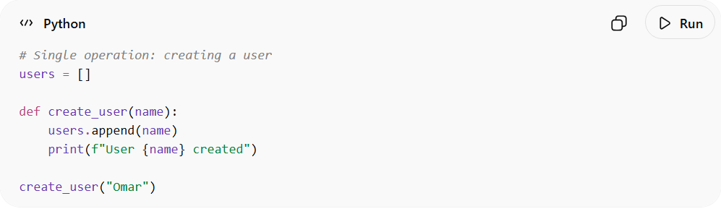
# Single operation: creating a user
users = []

def create_user(name):
users.append(name)
print(f"User {name} created")

create_user("Omar")

2. Transaction
# Source: AI Source: Provided by: [Data Path: Persons Table -> ID Column: 1, Name_En Column: Motasem Essam] -> From: [ChatGPT] on [2/12/2026]
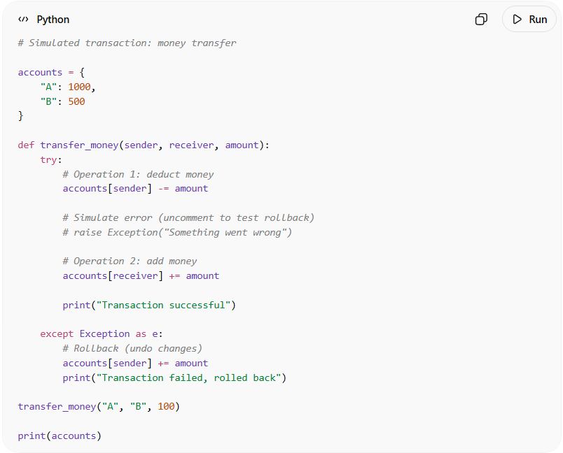
# Simulated transaction: money transfer

accounts = {
"A": 1000,
"B": 500
}

def transfer_money(sender, receiver, amount):
try:
# Operation 1: deduct money
accounts[sender] -= amount

# Simulate error (uncomment to test rollback)
# raise Exception("Something went wrong")

# Operation 2: add money
accounts[receiver] += amount

print("Transaction successful")

except Exception as e:
# Rollback (undo changes)
accounts[sender] += amount
print("Transaction failed, rolled back")

transfer_money("A", "B", 100)

print(accounts)
● Contains multiple operations
● Works as one unit
● If error happens → rollback

🎯 In one line
# Source: AI Source: Provided by: [Data Path: Persons Table -> ID Column: 1, Name_En Column: Motasem Essam] -> From: [ChatGPT] on [2/12/2026]
Transactions & Operations = the controlled actions that create, update, or delete data in a web system, ensuring data remains consistent and reliable.

